**Test Case** **0025**

**System:** VirtuCardsClient & VirtuCardsHost

**Description:** Tests that the username and player name can be changed

**Severity:** 3

**Instructions**

**Test1**

1. Start VirtuCardClient application
2. Click the button labeled “Sign In”
3. Enter “virtucards01@gmail.com” into the text input labeled “Enter email…”
4. Enter “Testing1” into the text input labeled “Enter password…”
5. Press the button labeled “Login”
6. A window should appear saying “Login Success”
7. Press the OK button that appears on that window
8. Press the Profile button on the top left of the screen

**Expected Result:** There is a screen that displays the profile information

**VirtuCard Client:**

Profile View screen

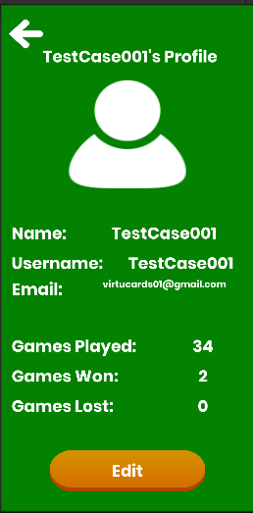

**Test2**

1. Start VirtuCardClient application
2. Click the button labeled “Sign In”
3. Enter “virtucards01@gmail.com” into the text input labeled “Enter email…”
4. Enter “Testing1” into the text input labeled “Enter password…”
5. Press the button labeled “Login”
6. A window should appear saying “Login Success”
7. Press the OK button that appears on that window
8. Press the Profile button on the top left of the screen
9. Press the Edit button at the bottom of the screen
10. Enter text into the Input boxes for Name and Username

**Expected Result:** There is a screen that allows the profile information to be edited

**VirtuCard Client:**

Edit View screen

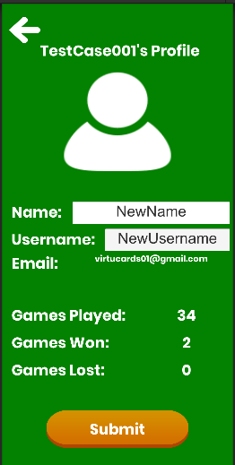

**Test3**

1. Start VirtuCardClient application
2. Click the button labeled “Sign In”
3. Enter “virtucards01@gmail.com” into the text input labeled “Enter email…”
4. Enter “Testing1” into the text input labeled “Enter password…”
5. Press the button labeled “Login”
6. A window should appear saying “Login Success”
7. Press the OK button that appears on that window
8. Press the Profile button on the top left of the screen
9. Press the Edit button at the bottom of the screen
10. Enter text into the Input boxes for Name and Username for a new username and player name, except the previous username
11. Press the Submit button
12. Press the OK button on the confirmation
13. After returning to the Join Game page, press the Profile button on the top left of the screen.

**Expected Result:** There is a screen that allows the profile information to be edited and then a confirmation message is shown indicating the change has been made. The database is updated with the new information.

**VirtuCard Client:**

Edit View screen

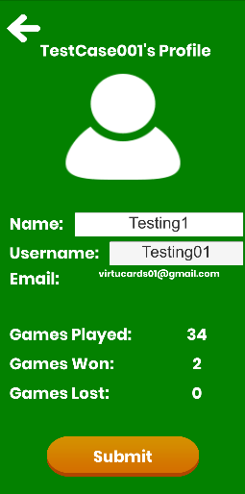

After pressing the submit button

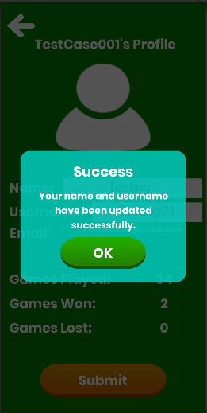

Information updated on the profile screen

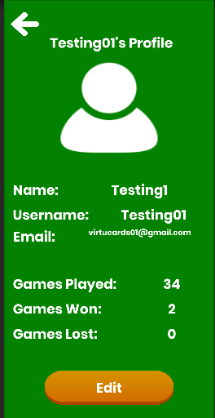

**Firebase:**

Profile information updated in database

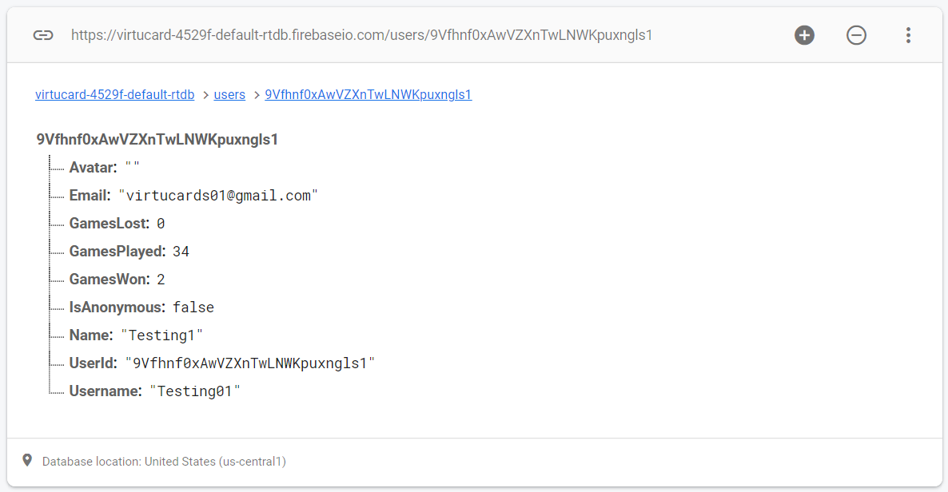

**Test4**

1. Start VirtuCardClient application
2. Click the button labeled “Play Anonymously”
3. Press the Profile button on the top left of the screen
4. Press the Edit button at the bottom of the screen
5. Press OK on the error panel that opens up

**Expected Result:** There is an error panel and the anonymous user is not allowed to change their profile data.

**VirtuCard Client:**

Profile View screen

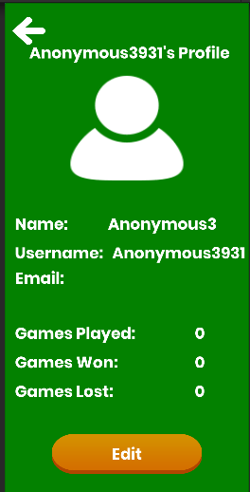

After pressing the Edit button

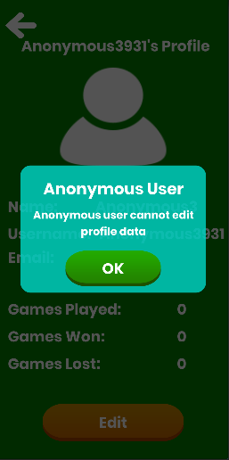

**Test5**

1. Start VirtuCardClient application
2. Click the button labeled “Sign In”
3. Enter “virtucards01@gmail.com” into the text input labeled “Enter email…”
4. Enter “Testing1” into the text input labeled “Enter password…”
5. Press the button labeled “Login”
6. A window should appear saying “Login Success”
7. Press the OK button that appears on that window
8. Press the Profile button on the top left of the screen
9. Press the Edit button at the bottom of the screen
10. Enter any string into the Input box for Name and enter “billgates34” in the Input box for Username. (existing username)
11. Press the Submit button
12. Press the OK button on error panel that pops up

**Expected Result:** There is a screen that allows the profile information to be edited. An error message is shown indicating that the username already exists.

**VirtuCard Client:**

Edit View screen

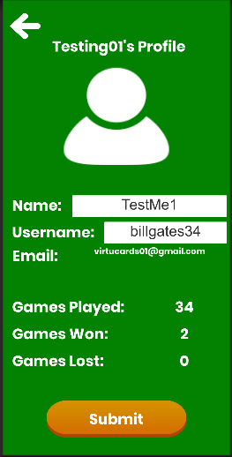

Error panel shown due to existing username being used

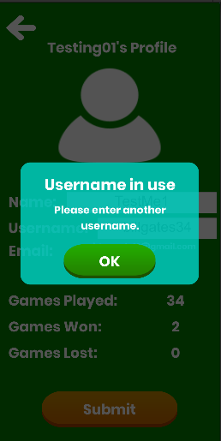

**Firebase:**

No changes made in the database

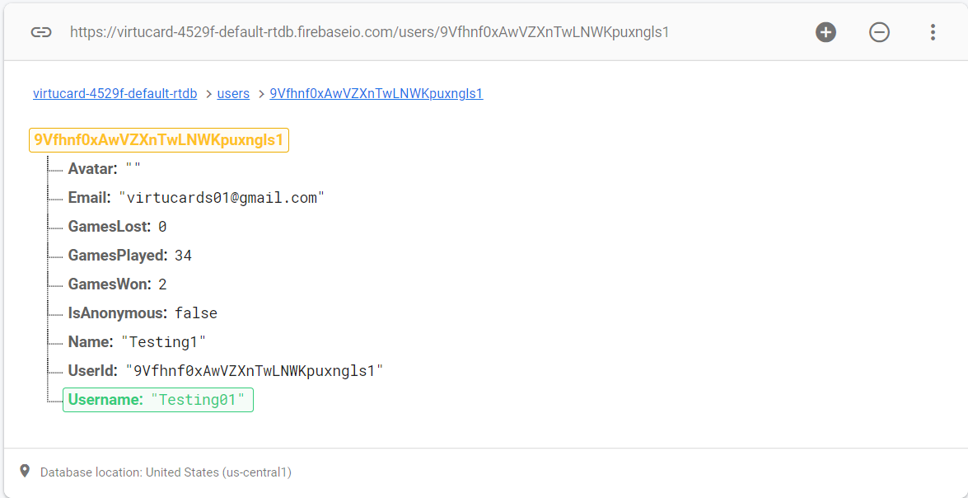

**Test5**

1. Start VirtuCardClient application
2. Click the button labeled “Sign In”
3. Enter “virtucards01@gmail.com” into the text input labeled “Enter email…”
4. Enter “Testing1” into the text input labeled “Enter password…”
5. Press the button labeled “Login”
6. A window should appear saying “Login Success”
7. Press the OK button that appears on that window
8. Press the Profile button on the top left of the screen
9. Press the Edit button at the bottom of the screen
10. Do not enter any strings into the Input Boxes for Name and Username
11. Press the Submit button
12. Press the OK button on error panel that pops up

**Expected Result:** An error message is shown indicating that both fields are empty.

**VirtuCard Client:**

Edit View screen

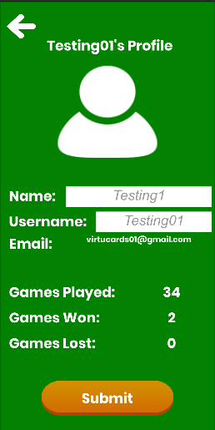

Error panel due to empty inputs

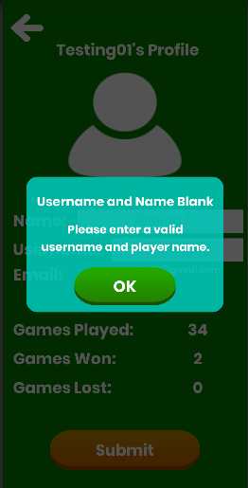

**Firebase:**

No changes made in the database

